Name: Misheck Sialutaba
Student Number:
Course: Web Development
Title: Wina Bwangu Web Application Requirements & System Modeling Architecture
Submission Date: 17th September 2026

Exercise 2: Client-Side Implementation:
- HTML5 & Bootstrap 5 Structure: Implements a fluid, responsive container layout with structured input groups, dynamic forms, and an accessible navigation bar.
- Client-Side Event Handling: Uses DOM JavaScript event listeners (DOMContentLoaded, change, submit) to monitor user selections and update form values without needing a page refresh.
- Dynamic Data Mapping: Leverages JSON key-value objects (boothLocations, boothServicesMap, serviceRates) to map locations, enforce booth-level service authorizations, and calculate revenue rates instantly.
- User Input Validation & Toasts: Intercepts default form submission via e.preventDefault() to run validation checks and triggers asynchronous Bootstrap Toast alerts to deliver immediate feedback to the operator.

Figure 1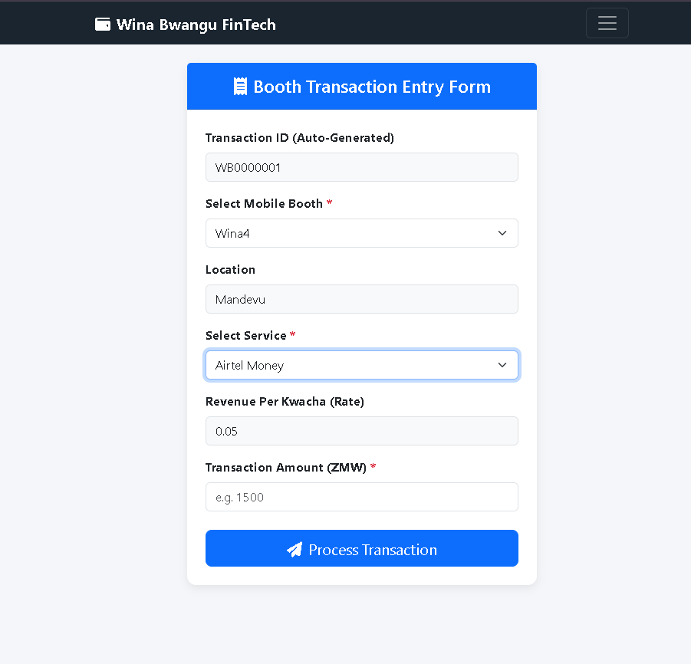
Figure 2
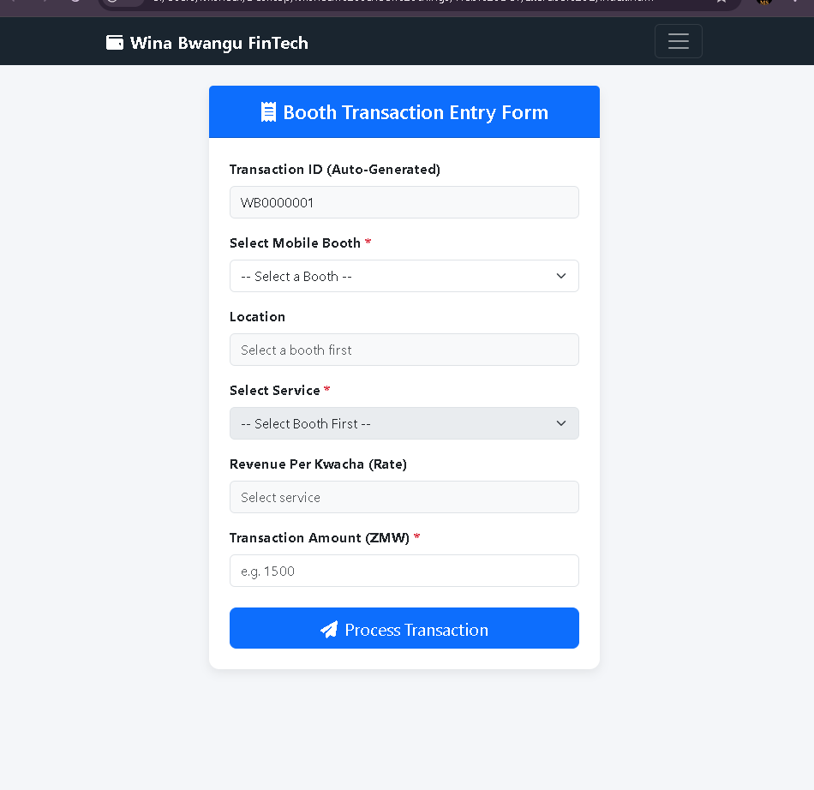

Figure 3
